
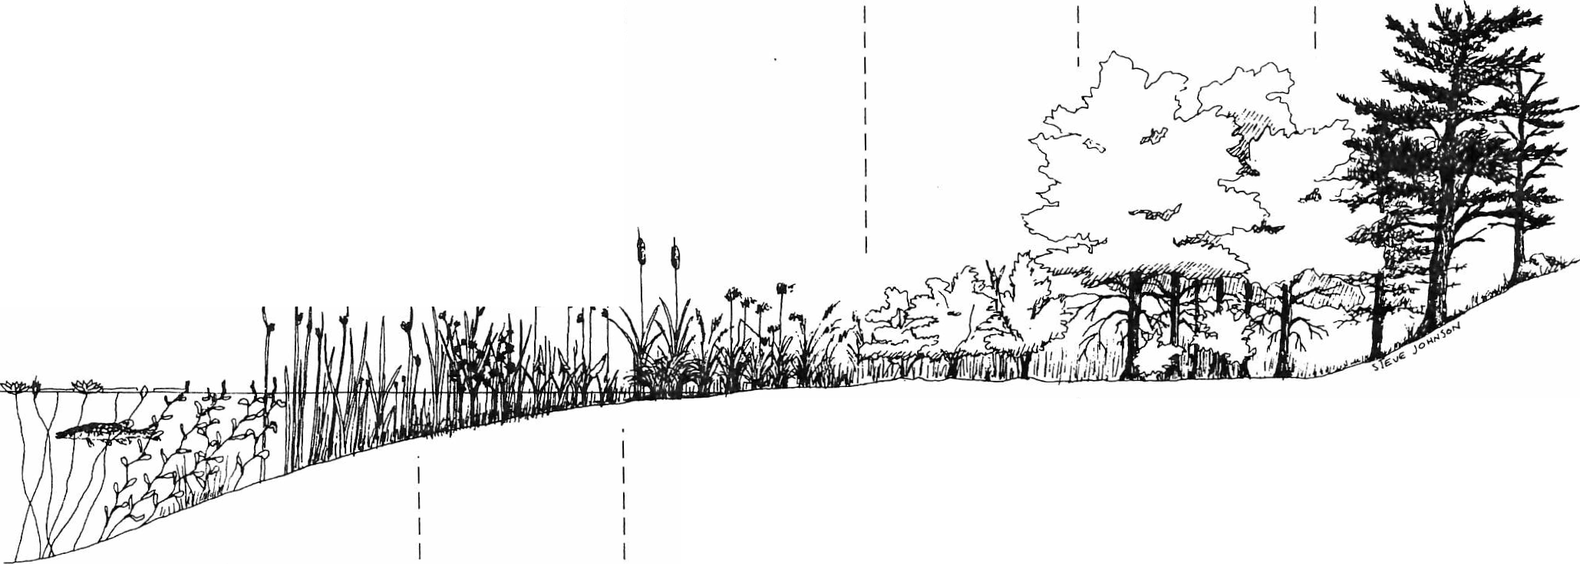
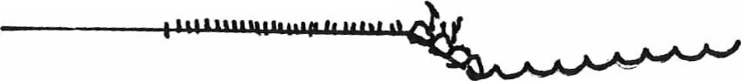
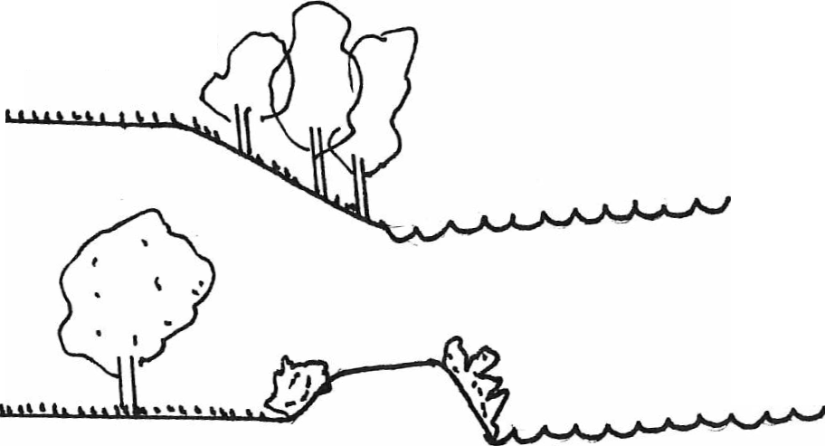

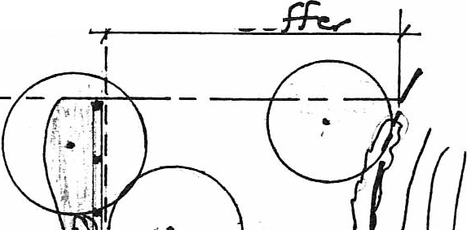
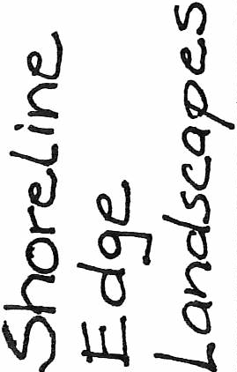
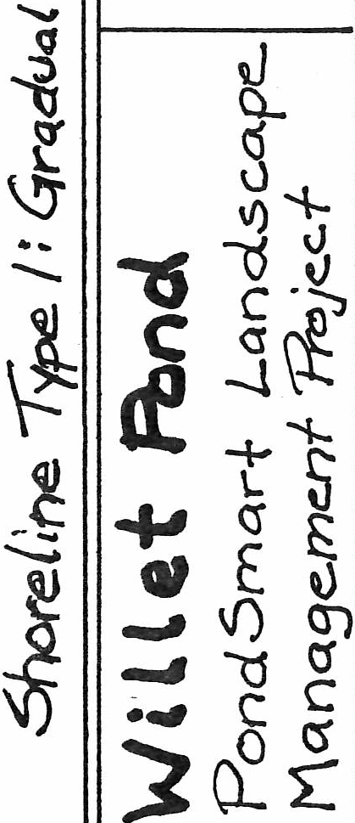
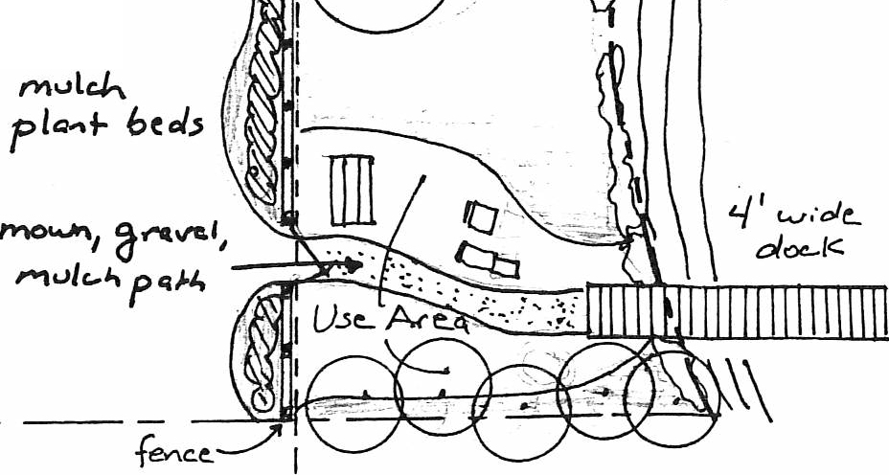

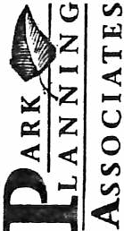
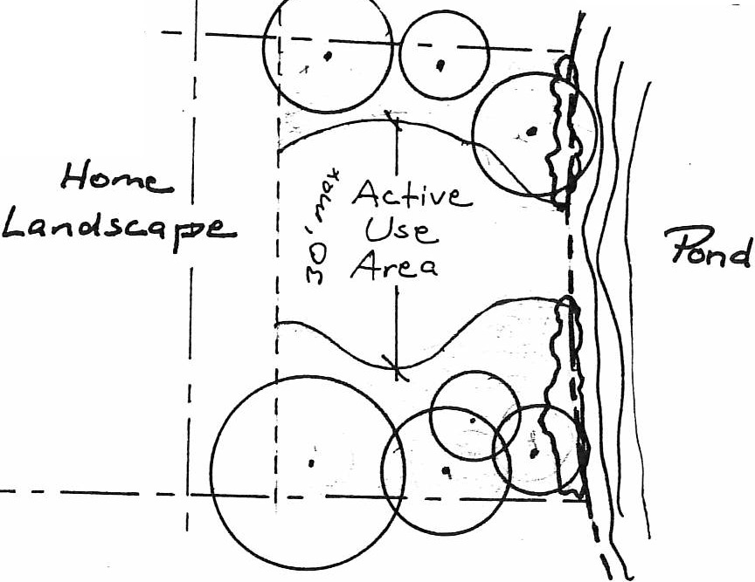
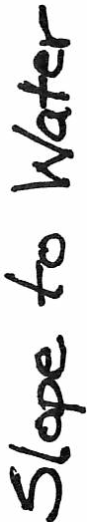
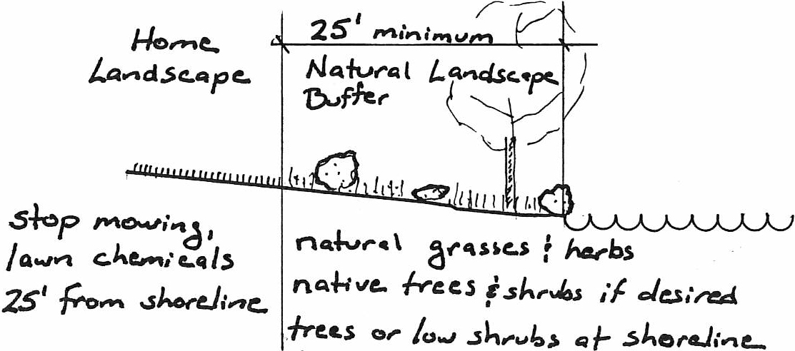
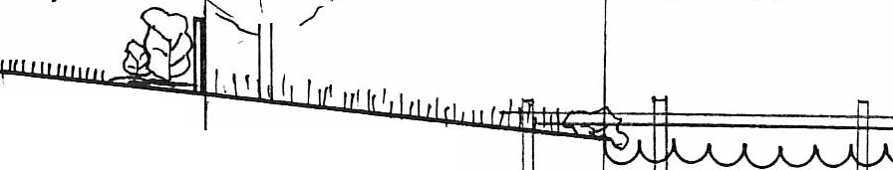

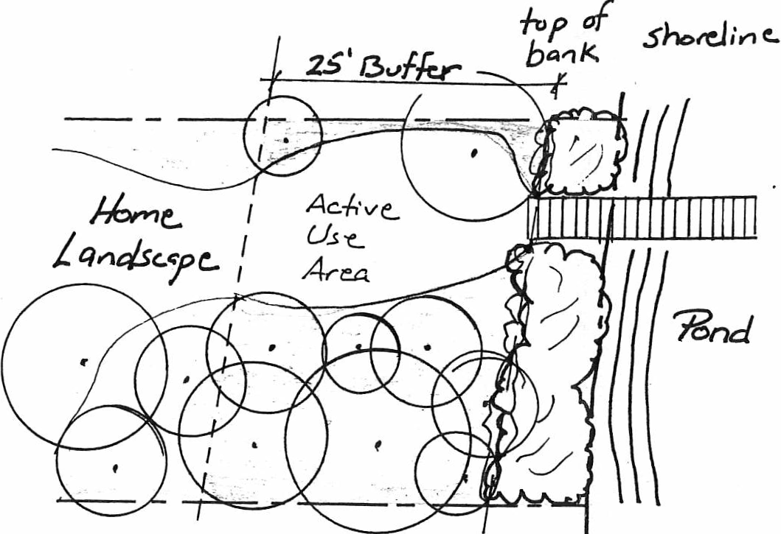
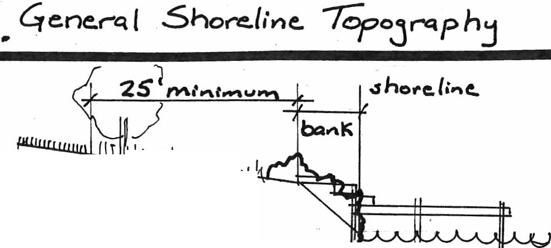

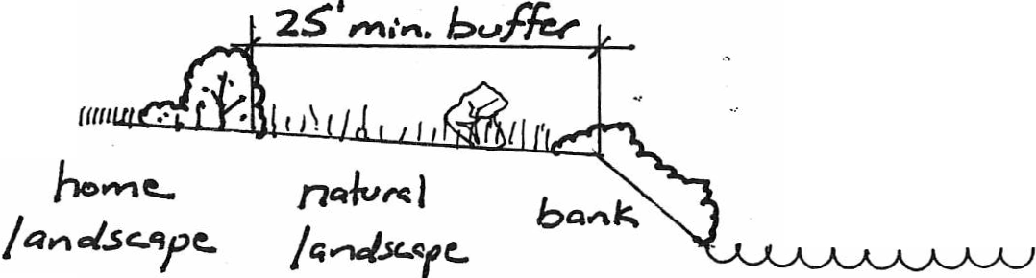
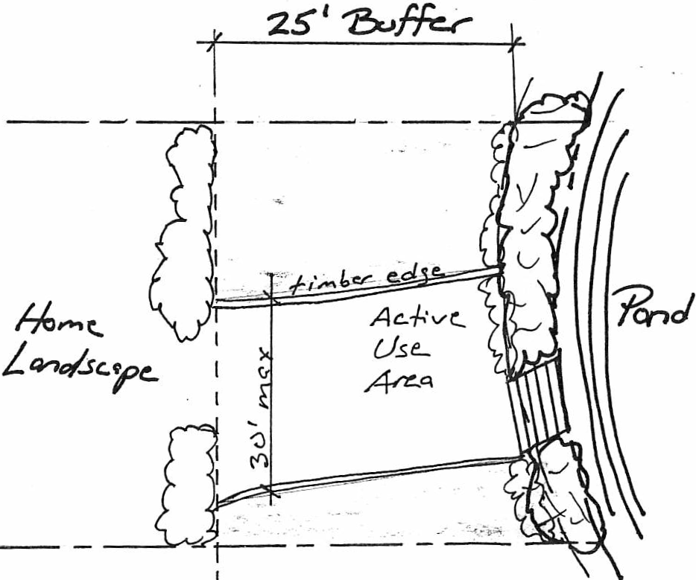
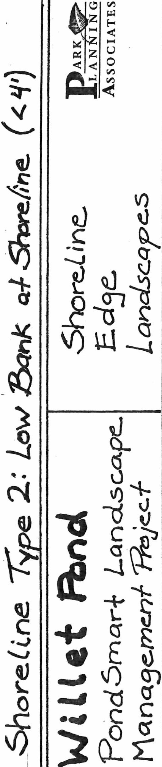


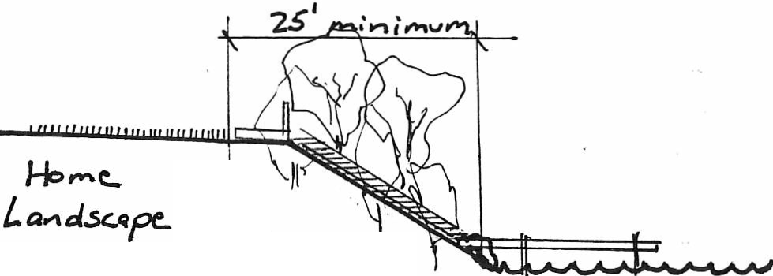
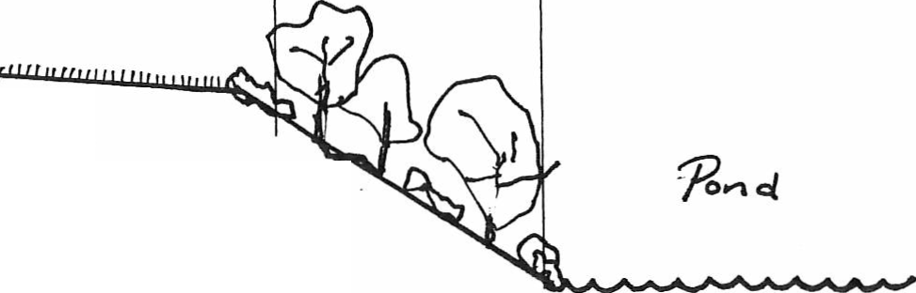
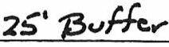
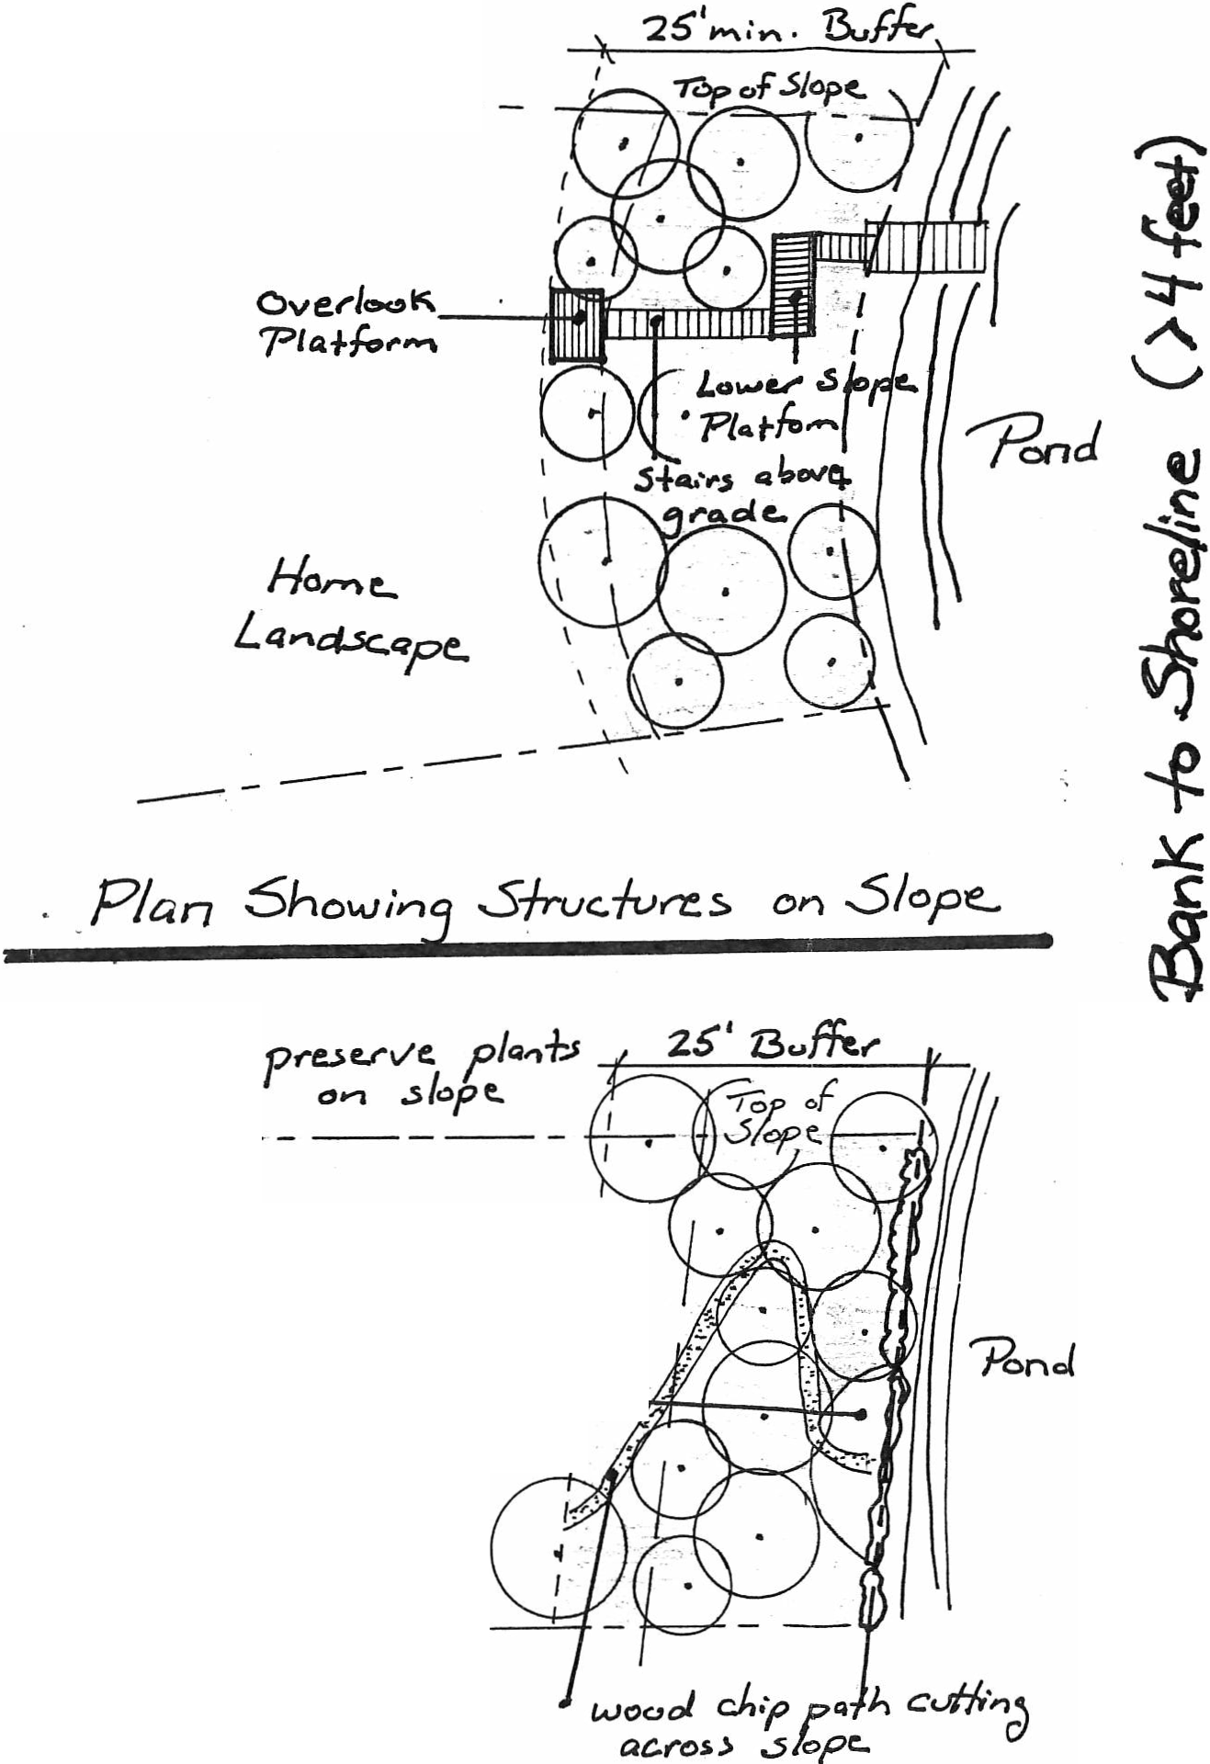
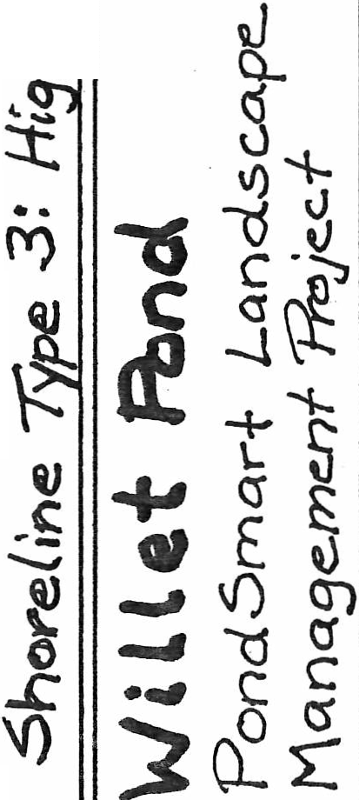
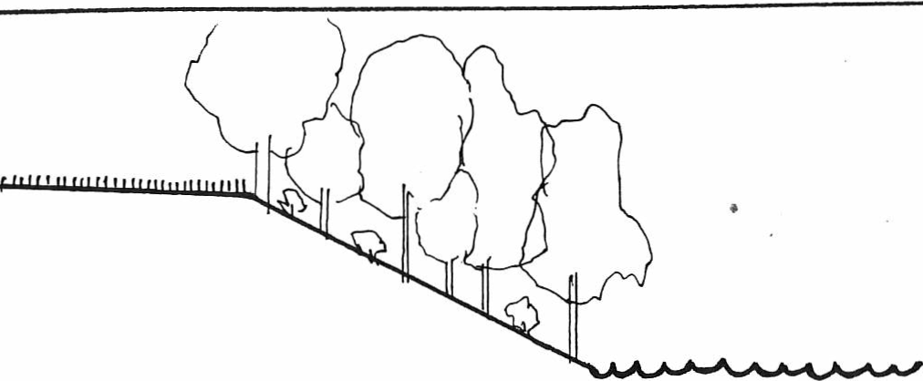
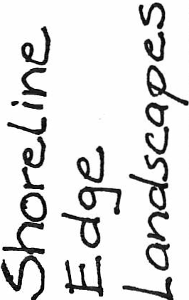

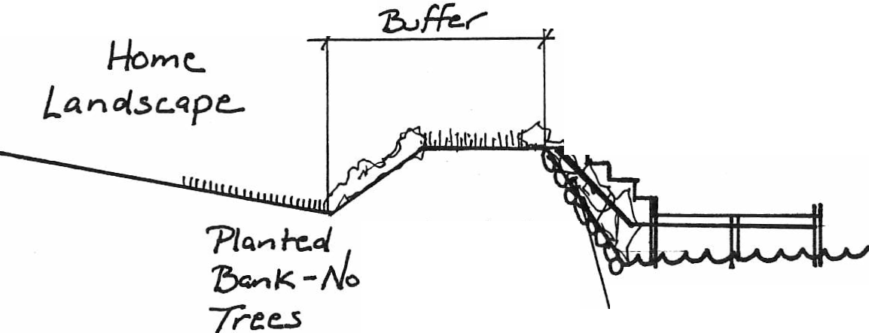

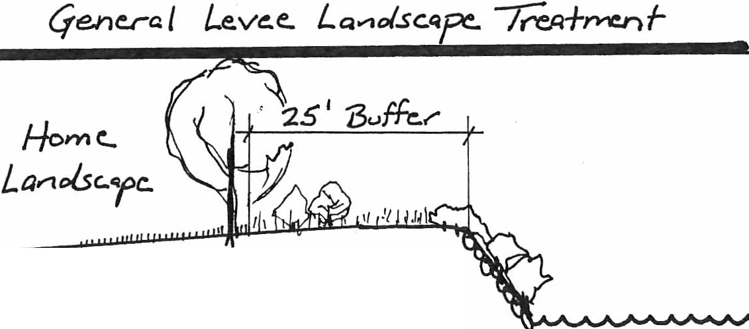
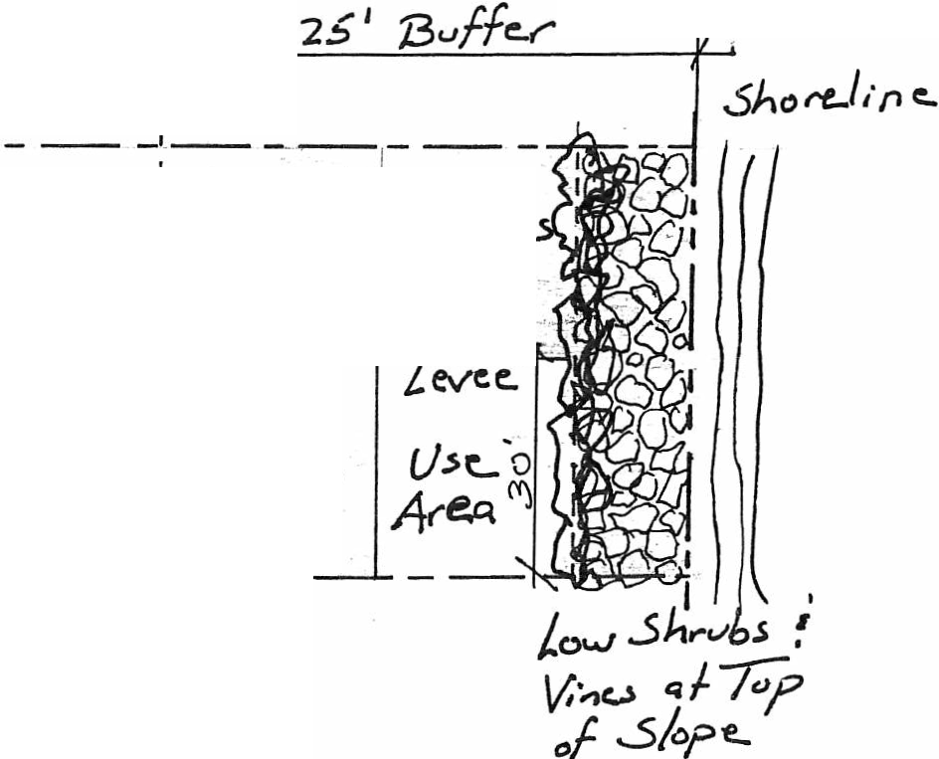
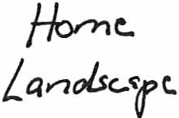
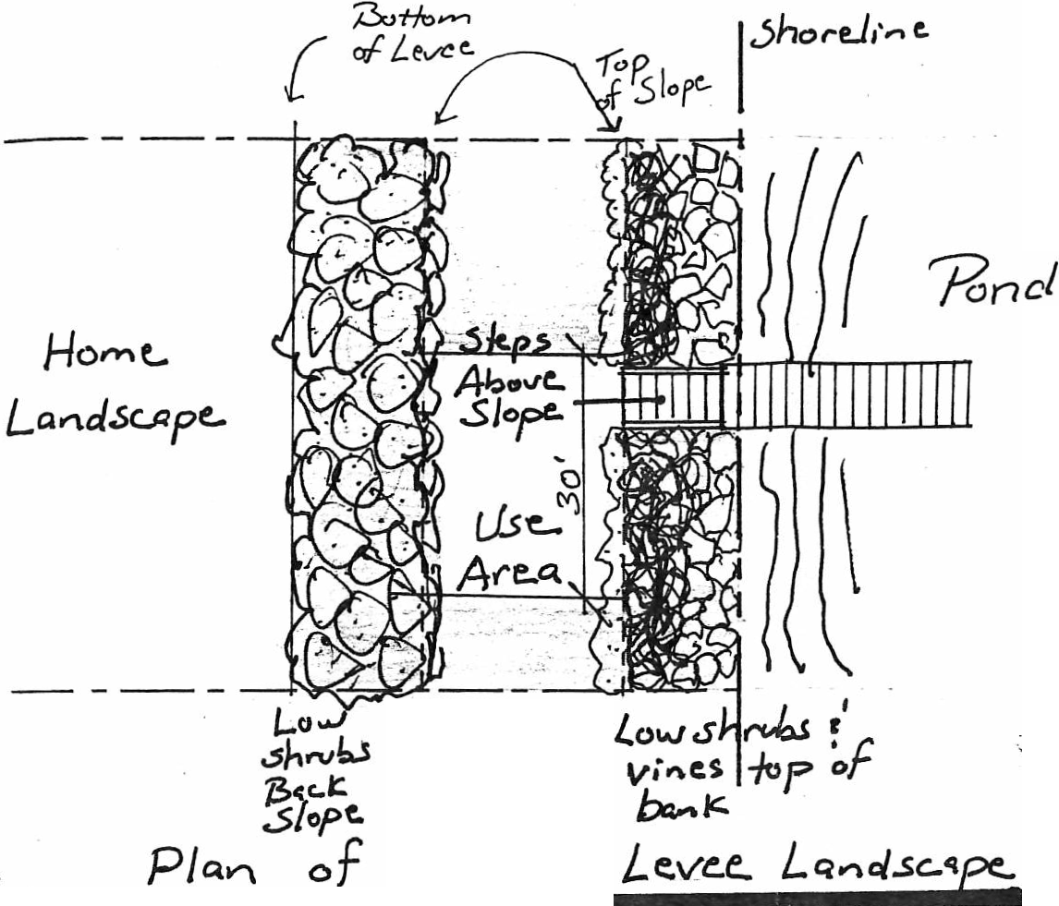
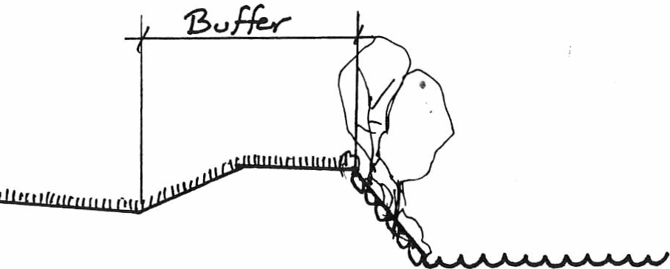
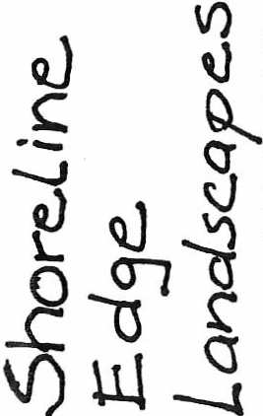
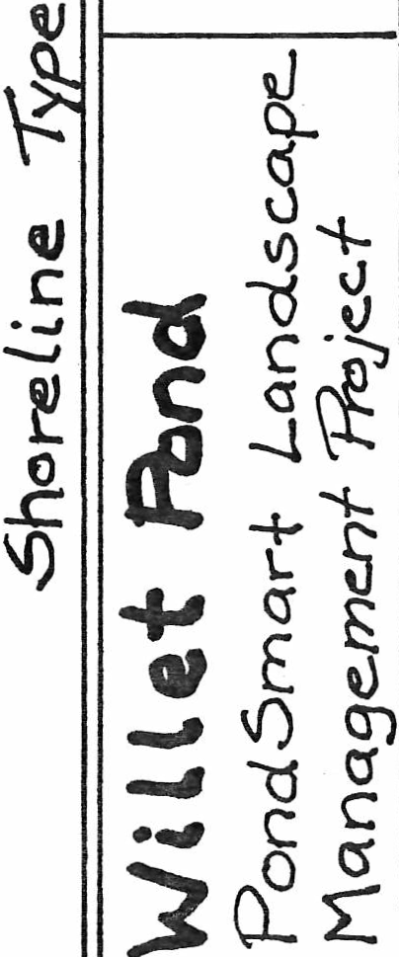

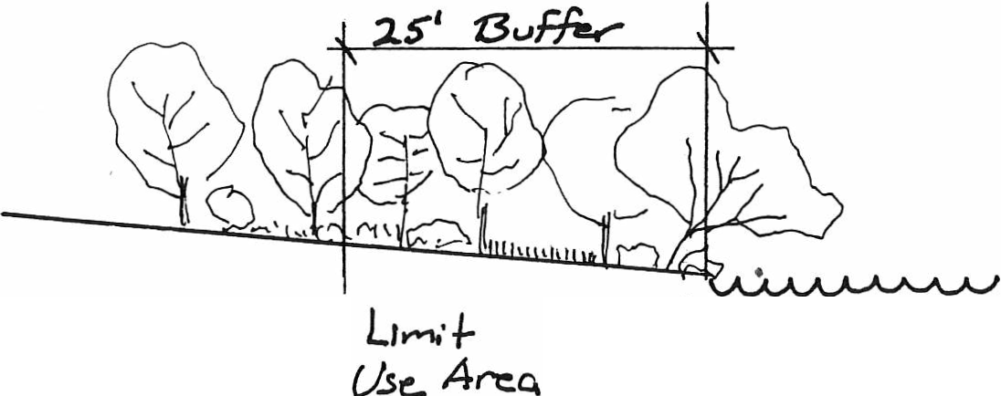
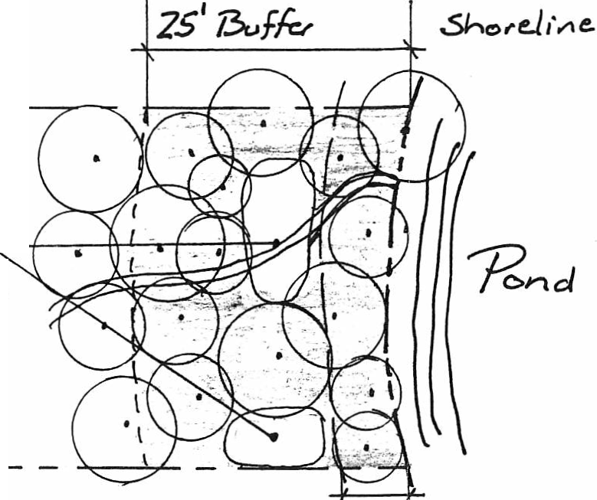

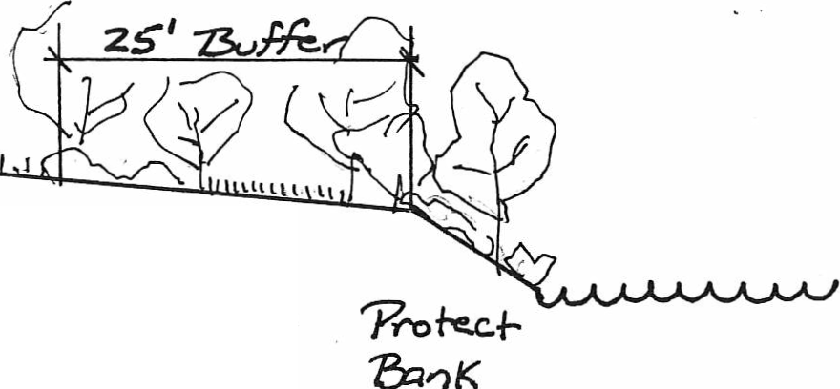
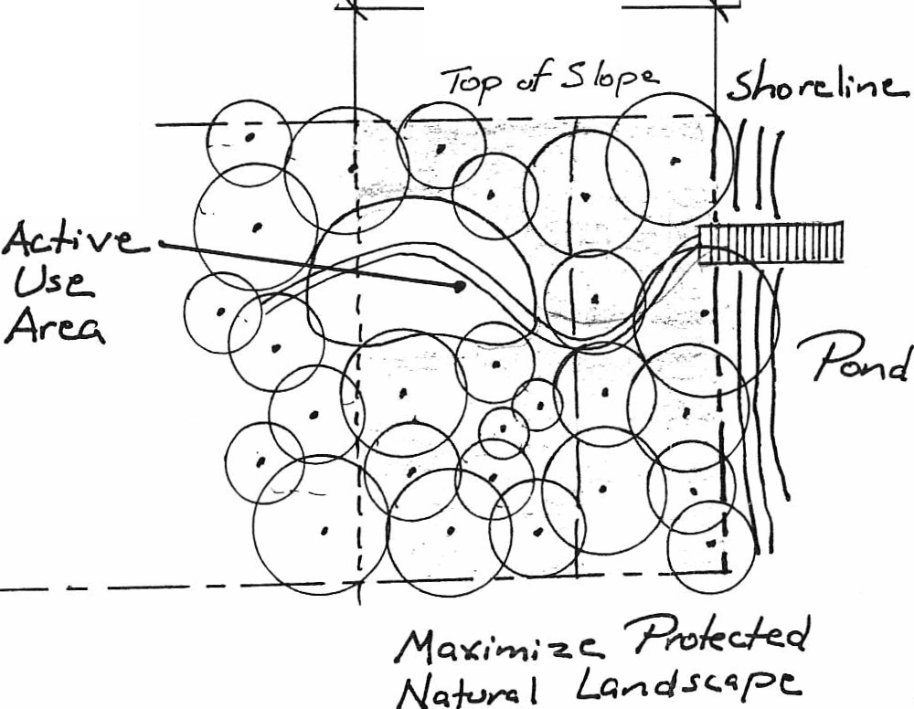
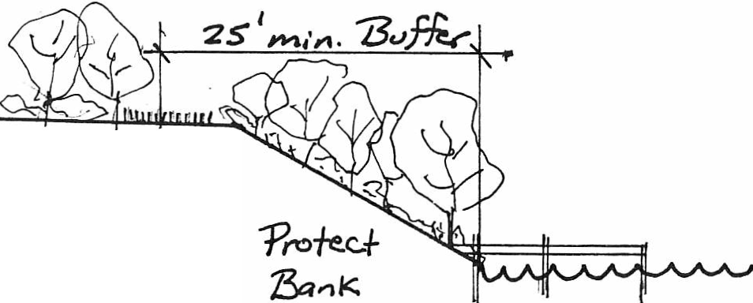
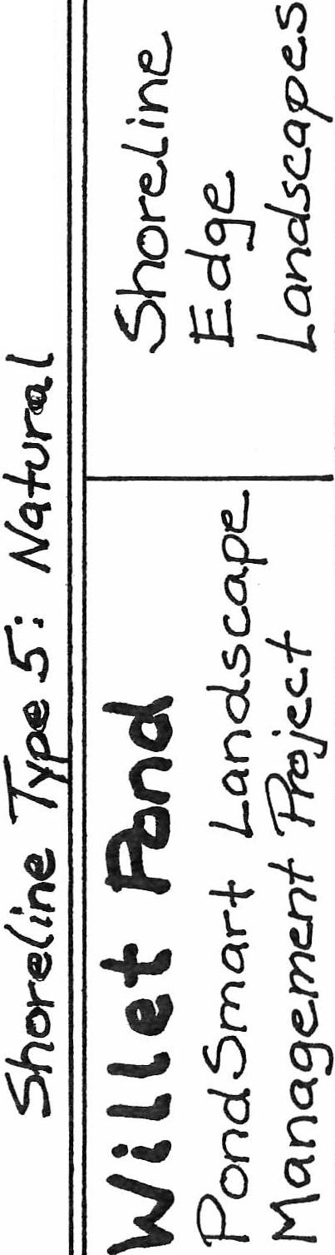
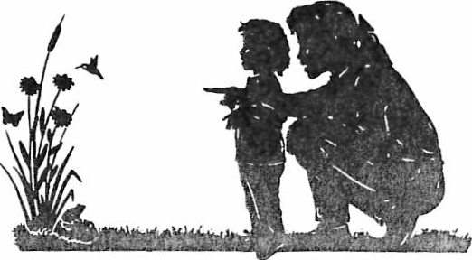
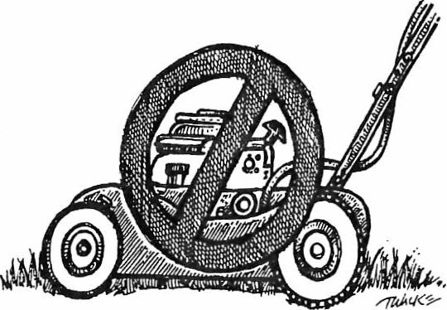
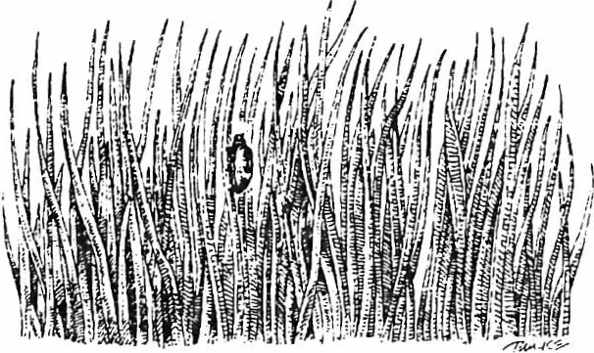
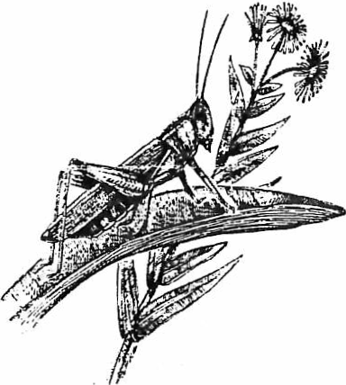
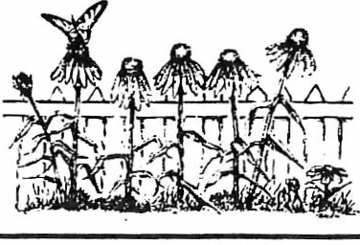
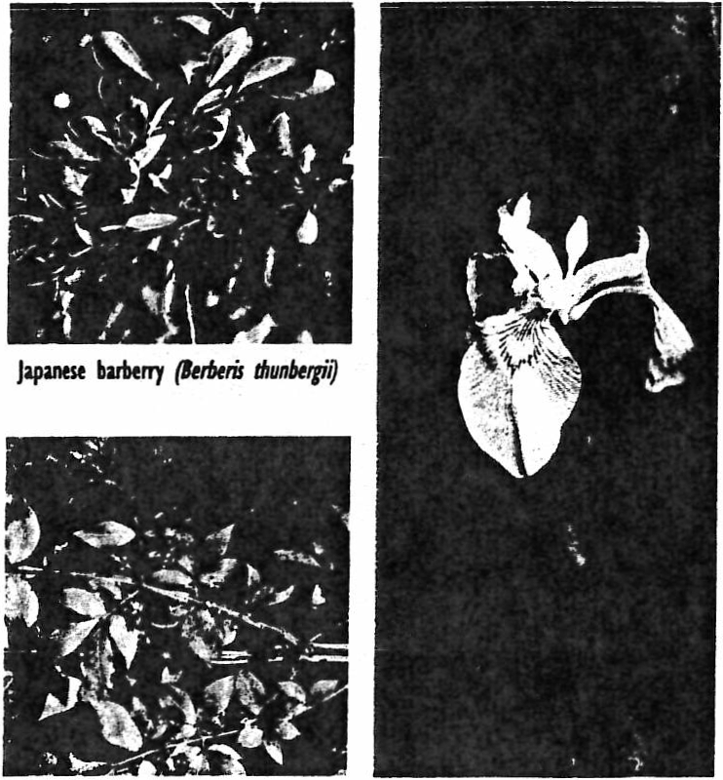



Willett Pond
PondSmart Landscape Management

This document provides general guidelines and applicable restrictions regarding landscaping your property. It is critical to always keep in mind that:

1.)For most of the homes on the Pond, Neponset River Landholding Association (“Landholding”) is the actual property owner of the shoreline and a “landstrip” which generally is 10-30 feet in depth surrounding the Pond. As such, any alterations of any kind require their approval.

2.) WPCPA must also approve of any alterations of any kind.

3.) The Walpole or Westwood Conservation Committees must also approve of alterations of any kind.

Our organization will help you in navigating these approval processes and offer suggestions. Please contact us at board@willettpond.org to learn more.

The primary design objective of the PondSmart Landscape Management Program is to create a twenty-five foot deep natural landscape buffer around the pond to protect water quality, enhance wildlife habitat, and reinforce the natural beauty of the pond. This is a summary – for further details, refer to the complete Pondsmart Landscape Management Plan which is in the lease or in a separate document.

Principles of PondSmart Landscaping

1. Eliminate use of chemical fertilizers, pesticides, and herbicides on NRLHA
property.

2. Use native plants and reduce or eliminate exotic invasive species.

3. Preserve or restore natural landscape buffer at least 25 ft landward from shoreline high water line or top of bank.

4. Preserve or restore native plantings on banks and three ft landward from top of bank to prevent erosion, irrespective of depth from pond.
(
5. Lsee "active use" area up to 30 ft wide (750 square ft) permitted
within buffer area.

6. Lessee use on NRLHA property beyond the 25 ft buffer is unrestricted within the following guidelines:
a. No structures, fencing, vegetation removal or new plantings without plan approval;
b. No use of chemical herbicides or fertilizers on NRLHA property in
landscape maintenance;
c. Existing naturally vegetated landscapes inland of 25 ft to be largely preserved.

7. Docks perpendicular to the shore, four feet wide, is the favored means of water and boat access.

8. Limiting use of chemicals and natural landscaping is strongly encouraged for home landscapes of all licensees, and no chemical applications are allowed within 100 feet of the water’s edge.

9. Downward directed, low voltage lighting that does not shine beyond the shoreline may be approved upon application to the Operating Committee—please contact WPCPA to learn more about this.

10. No new beaches are permitted. Existing beaches are grandfathered but may not be expanded. Beaches to be maintained by raking and weed removal (excepting use of chemical weed control).

11. Providing limited "view windows" to the pond by selectively pruning tree branches will be permitted. Proposed pruning must be reviewed in the field and approved by the three entities noted above prior to initiating work.

12. All proposed landscape plans for the 25 ft buffer must be developed in accordance with concepts shown on the Shoreline Types drawings included in the complete PondSmart Landscape Management Plan in the lease .

Willett Pond
PondSmart Landscape Management Program

Landscape Design Considerations

25 Foot Buffer

1. Stabilize bank and top of bank- The bank along the shoreline should be stabilized with trees and shrubs to prevent erosion and capture pollutants before they enter the pond.
2. Identify Needs for Water Access-Decide what activities you anticipate using the
pond, boating, fishing, swimming, skating, etc. Docks are encouraged for water and boating access because they are less impacting on the shoreline.
3. Identify Expected Uses for your "Active Use Area"- It is encouraged that active uses
of the pond shore area be located outside the 25' buffer to the greatest extent possible. These uses include picnic tables, lawn furniture, water play equipment, boating and swimming equipment, etc.
4. Think About Landscape Character of Buffer Area- What is the existing buffer area landscape like? Is it mostly trees and woodland? Maintained lawn? Do you prefer a more open, meadow type landscape or natural woodland?
5. Location, Size, and Ground Surface of "Active Use Area"-Maximum 25' x 30' (750
square feet). Do you need a mown lawn or could you use woodchips or other natural material?
6. Relationship to "Home Landscape"- Do you prefer a highly maintained home
landscape and therefore a sharp transition to buffer area? Do you like a more natural home landscape and a minimal transition from home to buffer?
7. Do you Want a Fence at Buffer Edge?-Safety for children, pets, control of geese,
buffer delineation.
8. Identify Invasive Plants - These species compete with native species leading to a less diverse ecology.
9. Plant Selection- Review plant lists provided in this notebook, review plant characteristics at on-line sites, in books, or at nursery.

Home Landscape

1. Home landscape is defined as everything beyond the 25 foot shore buffer. For land areas owned by NRLHA use of all native plants and elimination of chemical pesticides and fertilizers is required.
2. Views- Consider views to pond, active use area, and opposite shore. Also consider views to your property from the pond and opposite shore. The objective is to preserve a natural landscape character for everyone. Wide open landscapes facing the shore are
discouraged; narrowing your views will provide more dynamic viewing while lessening the impact on others.
3. Storage- Find places in this zone to store your lawn chairs, water toys, boating equipment, and landscape maintenance supplies to keep them out of the buffer area. Locating them to the edge of your space will lessen their impact on your landscape.
4. Access to Water- Consider how you move from your home to the pond. Do you
want a defined pathway or do you like walking across the grass? Undefined paths and curvilinear alignments are more attractive unless part of a very formal, symmetrical landscape design.
5. Gathering Areas - Decks, patios, or group gathering areas are more effective located
close to the house to be useful over more of the year and in varying weather conditions. Gathering areas closer to the shore should be flexible in their design and located outside the buffer area if possible.
6. Organization of Space - Consider making outdoor rooms with planting and other elements to create a variety of spaces and provide definition, separation, and privacy among uses. Concentrate plants along the edges to provide enclosure while saving the center of spaces for use and specimen plants.
7. Plantings-Use plant lists provided to select plants for your landscape. Research their
characteristics on-line, in books, and at nurseries. Make sure you do not buy plants from the Prohibited Plant List in Section 3 of the PondSmart notebook, or from the invasive lists provided. Strongly consider native alternatives before planting a non native plant.
Wetland Section
(with typical plant species for each zone)

Open Water
(Aquatic Bed)
Deep Marsh Shallow Marsh
(Emergent Wetland) (Emergent Wetland)
I I I I I I I I I I
I I I I I I I I I I I I I I I I I I
I I I I
I
I
Wet Meadow Scrub/Shrub
Wetland
Forested Wetland Upland Buffer

Water Depth
0"- 6"

Water Depth
3'- 7'

White Water Lily
Yellow Water Lily
Water Depth Water Depth
18" -3' 6"-18"
Soft-stem Bulrush Burreed
Hard-stem Bulrush Northern Arrowhead
Hydric soil characteristics

Cattails
Blue Flag Iris
Hydric soil characteristics

Silky Dogwood
Red-osier Dogwood
Hydric soil characteristics

Sweet Pepperbush
Spicebush

Non-hydric soils

White Pine
Eastern Hemlock
Pond Weeds
Wild Celery
Pickerelweed
Pickerelweed
1
Common Three-square ISoft-stem Bulrush
Blue Vervain
Joe-Pye Weed
Sweetflag
Highbush Blueberry
Northern Arrowwood
Swamp White Oak Red Maple Green Ash
Black Gum

....
Shadblow/Serviceberry
Sweet Fern
Gray Birch

New England Wetland Plants,Inc.,820 West St.,Amherst,MA01002
Phone (413) 548-8000 26 Fax. (413) 549-4000
New England Wetland Plants,Inc.,820 West St.,Amher.;t,MA 0I002
Phone (413) 548-8000 27 Fax (41 3) 549-4000
Willett Pond PondSmart Workshops
Shoreline Restoration Plant Lists

The following lists of native trees, shrubs, herbs, grasses, and ferns are suitable for use on land under the jurisdiction of the Neponset River Land Holding Association. For purposes of this project, native plants are defined as those plants which naturally occur in similar lakefront and adjacent upland locations in New England. The list was derived from a vegetation survey of the Willett Pond shoreline by ecologist Tom Palmer, and from "Ecological Associations of New England" as published in American Plants for American Gardens. These lists were then reviewed for the availability of plants in the local nursery trade and through the New England Wildflower Society.

Trees

Acerrubrum Red Maple Best maple for wet soils Alnus incana Speckled Alder Bank stabilization, wildlife Acer saccharinum Silver Maple Large, spreading, moist soils
Amelanchier Canadensis Shadblow or Serviceberry Small specimen, early spring flowers

Betula nigra River Birch Fast growing on banks, also beautiful landscape specimen

Betula populifolia Gray Birch White bark, multi-stemmed Cercis canadensis Redbud Early spring flowers Comus alternafolia Pagoda Dogwood Disease resistant dogwood
Nyssa sylvatica Sour Gum or Tupelo Beautiful along water Pinus rigida Pitch Pine Slopes and sandy soils Pinus strobus White Pine Not in shade, fast growing Populus deltoids Cottonwood Fast growing, wet soils
Populus tremuloides Quaking Aspen Fast growing, food for wildlife Quercus alba White Oak Important NE woodlands tree Quercus bicolor Swamp White Oak Can grow in seasonally wet soils Quercus palustris Pin Oak Moisture tolerant; wildlife food Quercus rubra Red Oak Slopes and landscape specimen Rhus typhina Staghorn Sumac Fast growing, red in fall, wildlife

I

Herbaceous Plants Achillea spp Asclepias incarnate Aster novae-angliae Aster novi-belgii Carex lacustris  Cephalanthus occidentalis  Chimaphila maculate | Yarrow  Swamp Milkweed New England Aster New York Aster Lake Bank Sedge Buttonbush  Striped Wintergreen | Excellent cut flower  Interesting seed pod, butterflies  Fall blooming  Lavender, common at Willett  Water edge, wildlife  Moist soils, glossy foliage  Low, fleshy-leaved evergreen
 |  | wildflower of dry, sandy woods.
Comptonia peregrina | Sweetfem | Bank stabilization
Coreopsis spp. | Tickseed | Yellow flowers all summer, sun
Dennstaedtia punctilobula | Hayscented Fern | Sun or shade, wet solis
Echinacea purpurea | Purple Coneflower | Adaptable, attractive dried flower
Eupatorium dubiwn Triple-nerved Joe-Pye-Weed Most common pink sp. locally
Eupatorium maculatum | Joe-Pye Weed | Tall, wet edges, wildlife
Eupatorium perfoliatum | Boneset | Tall, wet edges
Juncus effuses | Soft Rush | Tall clump grass growing in shallows
Lobelia cardinalis | Cardinal Flower | Brilliant red flowers
Monarda diyma | Beebalm | Fast spreading, summer flowers
Monarda fistulosa | Bergemot | 2-3' high fast spreading
Osmunda cinnamomea | Cinnamon Fern | Likes wet areas, wildlife
Panicum virgatum | Switch Grass | Tall grass, attracts wildlife
Peltandra virginica | Arrow Alum | Deep green, water edge
Phlox divaricata | Blue Woodland Phlox | Summer/fall, blue woodland flower
Rudbeckia hirtella | Black-eyed Susan | Summer flowering, naturalizing

Solidago rugosa Wrinkled Goldenrod Yellow flowers, wildlife value Thelypteris noveboracensis New York Fern Light green, strong grower Triadenum virginicum Marsh St. Johnswort Low, bushy, needs moist peat
Typha latifolia Common Cattail Important to wildlife, absorbs pollutants

Vernonia noveboracensis New York Ironweed Tall with pink to blue flower clusters

Vines

Arctostaphylos uva-ursi Bearberry Dry banks and woodlands

Parthenocissus quinquefolia Virginia Creeper Top of levee bank, berries and fall color

Verbena hastata Blue verbena Bushy herb with tall spikes of tiny blue or violet flowers

Vitis labruscum Fox grape Common grape vine

Vitis riparia Riverbank grape Wet areas, top of bank
\
'

For further information and photographs of these plants you can view them online at:

The National Plant Database: http://plants.usda.gov/index.html. This is a very scientific site and not so much design and cultivation information.
University of Connecticut Plant Database: http://www.hort.uconn.edu/plants/. This site has lots of nursery type trees and shrubs but not native herbaceous plants.

Good books for plant selection include:

Michael A. Dirr, Manual of Woody Landscape Plants
New England Wetland Plants, Inc., Amherst, MA, catalog, or www.newp.com William Cullina, Native Trees, Shrubs, and Vines, New England Wildflower Society Cathryn M. McDonough, Native Plants for Attracting Wildlife.

Willett Pond
Shoreline Types

1. Gradual Slope to Water

2. LoW Bank at Shoreline ( <4 feet)

3. High Bank to Shoreline ( >4 feet)

I''

4. Levee

5. Natural Edge-NRLHA Ownership (except patbfdock)

NRLHA ! 25 I Bvfft.,- j
PL 7."------...J-
1 Aor /.· c:_
• -----

2S'l3u

l3'l.s ,·c.. 13vfLa c..qp Conc.e.pc

1-J.o...,...,
e) Lo..,o/s pe_ J6.,.c.l
Hon-'\e_ 25 I¥\ •'n.
Lan.cJ. .Sc..Q pe )

Ooc.K.

Fe.nc..e.., 'Pft::i,.,f.'"jS
..fu e"'"'t se .,..c:..
fo.,.."""' q l /Q.""' aLs"l?e.

naNr'\ l IQ,.,aJ..sc.p c._ p L q, t-.·"1J.)

doc.K Pt:l"'
hove.. shcre.k,..e_

Iu· .'

•

'1
)

h \ l'tI T
I e>"""
n.:dv.r.; t ---......:..LI
11/lnd.st:.Ape. /o."'cl.st:.tpe..
prue.rve_ plq J..s c..,
.slcr=- Q"" ol lop
11"\t:.

"1 ;
'')

?ond
\
{ ,,)
)

....._
j .z
· z--<.
=: z u
< < 0

. 'P...-e.seJVe..
ve.,._fq,.,. CY\
Slope.

-C j '

1-/om
L1¥'\J.se.'f
'f?e.4e.N V5c.M ·
3 1 obove. /of of
..S/DjJt.

I
!-loMe... Lt: ndsc. e. /

I
I
U.se. areq fJ,.fuf. -;1 ---:--UJ:...
f Gfl" /- of hot>e.//,..,t.. I

sJ.ct;,...s qbove...

IIWLLL.I.w...J K

t Mea ...J
q U f
of Levee. Low ..shrcJh-5 c
herhac.cov..s f/ ;,., +.S

2
!.;..-a»O
7dp u{
!evec.
Lie.ne..r l

'
N , I ; 4.,-a $e .

-=•:;•,-
I L""otsurd c ,t · ·
Tre.e.s, ··
I..sh..v
qr4sses

G.ra.s .s fop
cf /..eve.e..
N .f-· LA,cl.sc.. Low sh..-ob!> f
;., 75uf hvhaa.c:> _j J>l&i
1
--t

e,:, 1-'l
. f-<
. - <
;:.:::· z -
z u
< < 0

-

Ll..n.· J..
0,·s.fv,-bal"l c.e.
Pro+e.c..+ Vf!J_e. .f,·o,.,
/0' fr-o. hoi"(!_
L-;-, ----:r-;t-:
c:.. use_

qJ
.c...

0
-C
V)

25 13uf

re.fvl Jj pt"vYle. vl f!.v.J w 1;'\dt>uJ..S pond

----

( .
NATIONAL
WllDUFE
FEDER ATIO N·•
Lawn Reduc!J'o!l...
Cut Your Lawn1'n flalf!

BACKYARD WILDLIFE
HABITAI
NATIONAL WILDLIFE FEDERATION

For over a century now, traditionalAmerican landscaping has focused on maintaining a perfectly manicured green lawn. Native trees, shrub masses, ground covers, prairie or meadow patches, flower beds, and attractively mulched areas are better environmental choices, for people and for wildlife.

Did you know that...
...approximately 20 million U.S. acres are planted as residentiallawn;
...a lawnmower pollutes as much in one hour as a car does driving for 350 miles;
...30-60% of the potable municipal water in the U.S. is used for maintaining lawns;
...67 million pounds of synthetic pesticides are used on U.S. lawns annually; and
...thase lawn monocultures offer little habitat value fo. ,vi!dlife?

Five good reasons to reduce your lawn:

1. Save time and money that you would normally spend on mowing and fertilizing (especially if you ue a lawn service).
2. lncre<!se your home's energy efficiency.
3. Attract and provide for wildlife visitors.
4. Conserve water.
5. Reduce mower pollution and decrease run-oft from fertilizers and pesticides.

If you are fed up with lawn maintenance, here are some alternatives to consider:

·• Native species as ground cover instead of grass
• Native trees and/or shrub masses
" Water garden or pond
• Rock garden
• Mulched path
Annual or perennial bed
Meadow or prairie patch
• Hedgerow
• Organic vegetable garden
• Butterfly or hummingbird garden
Before taking action...
Make a plan of how you want your yard to look. Check with your local municipality or neighborhood/homeowners association for regulations. Work in phases and start small. Once you have decided on a small area to convert, follow these simple steps:
1. Cover turf grass with 6-10 layers of newspaper (black&. white only) or brown cardboard. Make sure the sections overlap
one another so that grass and weeds will not come up between the cracks. Wet down the newspaper or cardboard.
2. Cover the newspaper or cardboard with a thick layer of mulch or dirt (4-6 inches).
3. Plant directly through the mulch and newspaper/cardboard. Waiting a few weeks during a rainy period can help soften the material, making it easier to plant through. If you know you're going to be planting trees or shrubs, dig the holes
before putting down the layers of newspaper/cardb•)ard and then layer the newspaper/cardboard around the holes.

Other things to consider:
• Determine what is thriving on your site now. Encourage native plants already present and replace exotic invasive species with native species.
• Mulch can reduce weeds and prevent erosion. Organic :nulches improve the soil with nutrients and increase water holding capacity.
• Borders of rock or wood can bring a sense of order to a ''wild garden" in an urban or suburban neighborhood. This may make your naturalistic landscape more acceptable tn neighbors.
• Don't forget to make a place for people as well. A bench or path will accommodate this nicely and add to your enjoyment.

In the mean time...
• Set a goal of reducing your lawn size.
• Use a mulching mower to avoid collecting and disposing of clippings.
• If you must water your lawn, do so early in the morning, deeper and less often.
• Allow different S!)ecies to grow with your lawn. Enjoy the diversity.
Allow yc.:.lawn tt. 90 durrnant in the heat of the summer.
• Use a grass variety that requires little pesticides, water, and fertilizer in your area.
• Contact your county extension service about environmentally responsible lawn practices for your region.
• Use a short native grass or a grass that matures at a lower height to reduce the need for mowing. Buffalo grass is one example that grows well in the southwest and plain states.
• If the size of your lawn permits, use the modern version of the "old fashioned" style push mower to help reduce pollution.

Helpful Organizations
National Wildlife Federation .nwf.org): NWF's Backyard Wildlife Habitat program educates and inspires people to enhance and maintain their landscapes'with the needs of wildlife in mind. People who restore habitat to their yards and improve their local environment by reducing the use of fertilizers, pesticides, and water, are recognized through a certification process.
Smaller American Lawns Tod*amel2.conncoll.edu/ccrec/
greennet/arbo/salt.html): S.A.L.T. is a campaign originating at Connecticut College that aims to reverse the modem obsession with the lawn by restoring home and industrial grounds to more harmonious productive ecologically sound naturalistic landscapes.
Wild Ones - Natural Landscapers, L .for-wild.org): Wild Ones is a grassroots organization that educates and shares information about landscaping using native species in developing plant communities.

Suggested Reading
Daniels, Stevie. The Wild Lawn Handbook. 223p. 1995.
Macmillan Publishing Co.
Rappaport, Bret. "To Mow or Grow," published in Wildflower, Spring 1996 issue.
Schultz, Warren. The Chemical-Free Lawn. 208p. 1989. Rodale
Press.
Taylor, Patricia. Easy Care Native Plants. 325p. 1996. Henry
Holt and Co.
Wilson, Willai m H. Landscaping with Wildflowers and Native
Plants. 96p.
1985. Ortho Information Services.

-----.,
,...--,
\

Web Sites
Resources

• Milton Outdoor Classrooms web site
(http://www.miltonoutdoorclassrooms.com)
• NWF website (www.nwf.org/backyardwildlifehabitat)
• \Vww.enature.com (native plant database by region)
• www.hort.uconn.edu/plants (plant database)
• NWF Wildlife University online courses for info on how to provide habitat (www.nwf.org/wildlifeuniversity)

Books
• Trees and Shrubs ofNew England by Marilyn Dwelley
• Birdscaping Your Garden by George Adams
• Growing and Propagating Wildflowers by William Cullina
• Native Trees, Shrubs & Vines by William Cullina
• The Backyard Bird Feeder's Bible by Sally Roth
• Bird Gardens: Welcoming Wild Birds to Your Yard, Stephan
W. Kress (editor)
• Attracting Birds to Your Backyard by Sally Roth

Local Sources ofNative Plants & Bird Supplies
• Ocean State Job Lot--Birdseed, peanut feeders, suet,
• Blue Hills Trailside Museum--Birdseed, birdfeeders, bird houses, field guides
• Wild Birds Unlimited, 386 Columbia Rd. (Rte 53), Hanover, (781) 826-1640--Birdseed, birdfeeders, birdbaths, etc.
• New England Wildflower Society (www.newfs.org)-- Native plants sold at Garden in the Woods, Framingham
• City Natives operated by the Boston Natural Areas Network (www.bostonnatural.org)-- Native plants sold by appointment at City Natives, 30 Edgewater Drive, Mattapan Square. Contact Jeremy Dick, (617) 542-7696, for more information.

Milton Outdoor Classrooms
• Janet MacNeil (698-7013, janetmacneil@corncast.net); Mary Truslow (696-6050, mtruslow@corncast.net); Pete Jackson (696-2834, pjacks@comcast.net).
How to Create a Backyard Habitat

In cooperation with the National Wildlife Federation, Milton Outdoor Classrooms is starting a project to turn Milton into a community habitat for birds and butterflies. We invite you to join us in this important effort by creating a habitat in your backyard. The best plants for habitats are native plants (plants that are originally from this area). They require less water and maintenance than other exotic species because they are naturally adapted to our
environment. So everybody wins-the birds, the butterflies, and you!
•·.

Creating a backyard habitat is easy and really fun! Here's how:

1. Make a map of your backyard, showing:

The existing plants that might provide food (such as acorns, nuts, berries, seeds, buds, or nectar) for wildlife,
Birdfeeders,
Birdbaths or other water sources,
Plants that provide shelter (such as dense shrubs,
evergreens, brush piles), and
./ Places for birds and wildlife to raise their young
(trees, shrubs, birdhouses).

The map does not have to be fancy or extremely detailed, and is a fun way to become more familiar with your space.

2. Think about what types of birds and butterflies you want to attract to your yard. Research the types of plants and trees that will attract them (i.e., provide food, shelter, and/or places to raise young). The National Wildlife Federation's (NWF's) Backyard Habitat web site is a good place to start:
www.nwf.org/backyardwildl ifehabitat.

3. If you don't have them already, plant some of your favorite wildflowers, shrubs, and/or trees that will attract wildlife and provide food, shelter, and places to raise young.

4. Make sure that your backyard has a year-round source of water. This can be as simple as the bottom of a clay pot (for the summer) and a basic heated birdbath for the frigid winter months.

5. Get certified as an official NWF Backyard Habitat (see the NWF web site for the certification application) and watch the birds enjoy your efforts!

If you need assistance with any of these steps, contact the Milton
Outdoor Classrooms Team (see last page).We're happy to help!

Plants for Attracting Birds & Butterflies
to Backyard Habitats in Milton (Partial List)

Sweet pepperbush Redosier dogwood Spicebush Viburnums Winterberry
--

Birdfeeder Menu

WildOowers
Beebalm
Black-eyed susans Brown-eyed susans Purple coneflower

Vines Trumpet vine Virginia creeper

Shrubs
Bayberry
Low bush blueberry High bush blueberry Mountain laurel Sweet fern
Trees
American hornbeam American mountain ash Common witchhazel Eastern red cedar
Oak
Paper birch Quaking aspen Sassafras Serviceberry Shadbush Striped maple White pine

INVASIVE PLANTS
Know them-Don't grow them

Don't buy these plants
Although experts have determined that these plants arc invasive in most of New England, and harmful to the envi ronment,.the plants listed in bold are still widely available in catalogs and nurseries.
Norway maple
Bishop's weed Garlic mustard Japanese barberry Oriental bittersweet
Acer platanoides
Aegopodium podagra.ria Allia1·ia petiolatn Berberis thunbergii Celam·us orbiculatus
Swallowworts Cynanchum nigrum and C. 1•ossimm
Autumn olive Elaeagnus umbellata Burning bush Euonymm alatus Glossy buckthorn Frangula alnus Yellow flag iris Iris pseudacorus
Blunt-leaved privet Ligustrum obtusifolium
Shrub-like honeysuckles Lonicera morrowii, L. x bella, L. maackii, L. tatarica
Japanese honeysuckle Purple loosestrife Water-milfoils

Common reed
Japanese knotweed

Common buckthorn
Multiflora rose
Water chestnut
Lonicera japonica
Lythrum salicaria Myriophyllum aquaticum, M.heterophyllum, M. spicatum Phragmites australis Polygonunt cuspidatum (Fallopia japonica)
Rhamnus cathartica Rosa mttltiflora Trapa natans

Burning bush (Euonymus 2/ tus) Yellow ftag iris (Iris pstudmrvs)

What are invasive plants?
These non-native plant species are ..overachievers." Once established in natural areas, they outcompete native species. ln\"asivc plants cause profound environmental and economic damage, and are a major threat to native habitats world"ide. Some im·asives ha\'e escaped from our home gardens and public plantings into natural areas. Each state has different problematic plants. Sec other side for our top 20 offenders; for a complete list visit www.newenglandwildflower.org.
For a list of our recommended substitute plants and information about methods for removing invasive plants visit www.newengl a nd,,iJdflower.org.

How you can help
• Learn which plants are invasive in }'Our state.
• Purchase and grow only non -invasive plants.
• Ask your local garden center/nursery to stop selling invasive plants.
• Volunteer in your commuruty to help control in\"asivc plants.
• Inform your community about the threats posed by invasive plants.
C> 1001..., Eotl>d Wild flowtr Sootry. l'hor0f1P17 tf )apw< luborrr br Lui•• J. "•hrllofl.
Mro"" CMstoplotr lbnnd. ,.... a., iris Dorothy t Lter. Pnnrtd .. "<fdtd ,.,.,. • ...

Proposed Prohibited Plant List
**AS OF JANUARY 1, 2006, the importation of all plants on the list are prohibited. The one and three year phase-out periods are allowed only on plants that have entered the state prior to Januarv 1,
2006 and remain in the channels of trade within the commonwealth.

Importation- January 1,

Acer plataniodes

Acer pseudoplatanus
Norway maple

Sycamore maple
Two-Step-Phase Out 2006
Sale- January 1, 2009
Importation- January 1,
Two-Step-Phase Out 2006 · Sale- January 1, 2009
Aeginetia

Aegopodium podagraria

Ageratina adenophora
Ailanthus altissima
Alectra Thunb.

Bishop's goutweed; bishop's weed; goutweed
crofton weed
Tree of Heaven
January 1, 2006

January 1, 2006

January 1, 2006
January 1, 2006
January 1, 2006
Alliaria petiolata Alternanthera sessilis Ampelopsis brevipedunculata
Anthriscus sylvestris
Garlic mustard January 1, 2006 sessile joyweed January 1, 2006
Porcelain-berry; Amur peppervine January 1, 2006
Wild chervil January 1, 2006

Arthraxon hispidus

Asphodelus fistulosus
Avena sterilis
Azolla pinnata
Hairy joint grass;jointhead; small
cart:>etgrass
onion weed
animated oat mosquito fern

January 1, 2006

January 1, 2006
January 1, 2006
January 1, 2006
Importation- January 1,
Berberis thunbergii
Japanese Barberry
Two-Step-Phase Out 2006
Sale- January 1, 2009

Berberis vulgaris Cabornba caroliniana Cardamine impatiens
Carex kobomugi

Carthamus oxyacantha Bieb. Caulerpa taxifolla
Celastrus orbiculatus

Centaurea biebersteinii Chrysopogon aciculatus Commelina benghalensis Crupina vulgaris
Cuscuta

Cynanchum louiseae

Cynanchum rossicum Digltaria abyssinica Digitaria scalarum Dlgitaria velutina Drymaria arenarioides
Egeria densa
Common barberry; European
barberry
Carolina Fanwort; fanwort
Bushy rock-cress; narrowleaf bittercress
Japanese sedge; Asiatic sand
sedge
wild safflower

Oriental bittersweet; Asian or
Asiatic bittersweet
Spotted knapweed
pilipiliula
Benghal dayflower common crupina Dodder
Black Swallow-wort; Louise's
swallow-wart; Autumn olive
European swallow-wort; pale

African couch grass velvet flngergrass alfombrilla

Brazilian waterweed; Brazilian

January 1, 2006

January 1, 2006

January 1, 2006

January 1, 2006

January 1, 2006
January 1, 2006

January 1, 2006

January 1, 2006
January 1, 2006
January 1, 2006
January 1, 2006
January 1, 2006

January 1, 2006

January 1, 2006
January 1, 2006
January 1, 2006
January 1, 2006
January 1, 2006

January 1, 2006

Eichhornia azurea Elaegnus umbellatta Emex australis Emex spinosa
Epilobium hirsutum
eloda
anchored waterhyacinth
Autumn Olive
three-cornered jack devil's thorn
Hairy willow-herb; Codlins and
Cream

January 1, 2006
January 1, 2006
January 1, 2006
January 1, 2006

January 1, 2006

Importation- January 1 ,
Euonymus alatus

Euphorbia esula Euphorbia cyparissias F stuca filiformis
Frangula alnus

Galega officinalis

Glaucium flavum
Winged euonymus; Burning Two-Step-Phase-Out 2006
Bush Sales- January 1, 2009
Leafy Spurge; Wolfs Milk January 1, 2006
Cypress spurge January 1, 2006
Hair fescue; fineleaf sheep fescue January 1, 2006 ih:buckthorn; glossy January 1, 2006
goatsrue January 1, 2006
Sea or horned poppy; yellow hom Ja uary 06
poppy n ,

Glyceria maxima

Heracleum mantegazzianum
Hesperis matronalis
Homeria
Humulus japonicus
Hydrilla verticillata

Hydrilla verticillata
Hygrophila polysperma lmperata brasiliensis
Tall mannagrass; reed mannagrass
Giant hogweed Dames Rocket Cape tulip Japanese hops hydrilla
Hydrilla; water-thyme; Florida
elodea Miramar weed Brazilian satintail

January 1, 2006
January 1, 2006
January 1, 2006
January 1, 2006
January 1, 2006
January 1, 2006
January 1, 2006
January 1, 2006 (
January 1, 2006

Ipomoea aquatica Forsk.

Iris psudacorus
Chinese waterspinach *January 1, 2006

Yellow Iris Two-Step-Phase
Out
*Permit required - contact
Department
Importatoi n- January
1,2006
Sale- January 1, 2007
lschaemum rugosum
Lagarosiphon major

Lepidium latifolium

Leptochloa chinensis
Ligustrum obtusifolium
Limnophila sessiliflora
murain-grass oxygen weed
Broad-leafed pepperweed; tall
pepperweed
Asian sprangletop
Border privet ambulia
January 1, 2006
January 1, 2006
January 1, 2006

January 1, 2006
January 1, 2006
January 1, 2006

Lonicera japonica

Japanese honeysuckle
Two-Step-Phase Importation- January
1,2006
Out Sale- January 1, 2009
Importation- January
Lonicera maackii
Amur honeysuckle Two-Step-Phase
Out
1, 2006
Sale- January 1, 2009

Lonicera morrowii

Lonicera tatarica

Lonicera x bella [morrowii x
tatarica)

Morrow's honeysuckle

Tatarian honeysuckle

Bell's honeysuckle
Two-Step-Phase
Out
Two-Step-Phase
Out
Two-Step-Phase
Out
Importation- January 1,2006
Sale- January 1, 2009
Importation- January 1 ,2006
Sale- January 1, 2009
Importation- January 1,2006
Sale- January 1, 2009
Lycium ferrocissimum
Lysimachia nummularia
African boxthorn
Creeping jenny; moneywort
January 1, 2006
January 1, 2006

Page 3 of4

Lythrum sa!icaria Melaleuca quinquenervia Melastoma malabathricum
Microstegium vimineum

Mikania cordata Mikania micrantha Mimosa diplotricha Mimosa invisa Mimosa pigra L.
Purple loosestrife melaleuca

Japanese stilt grass; Nepalese browntop
mile-a-minute mile-a-minute

giant sensitive plant catclaw mimosa
Plume grass; Amur
January 11 2006
January 11 2006
January 11 2006

January 1 2006

January 11 2006
January 11 2006
January 11 2006
January 11 2006
January 11 2006
Importation- January 1,2006
Miscanthus sacchariflorus

Monochoria hastata
Monochoria vaginalis
silvergrass monochoria pickerel weed
Two-Step-Phase Out Sale- January 11 2007
January 11 2006
January 11 2006
Importation- January 112006
Myosotis scorpioides
Forget-me-not Two-Step-Phase Out Sale- January 1
Parrot-feather; water-feather;
2007
Myriophyllum aquaticum

Brazilian water-milfoil
January 1 2006
Myriophyllum heterophyllum

Myriophyllum spicatum

Najas minor Nassella trichotoma Nymphoides peltata Opuntia aurantiaca Orobanche L.
I Oryza longistaminata
Oryza punctata
Oryza rufipogon Griffiths Ottelia alismoides Paspalum scrobiculatum Pennisetum clandestinum
Pennisetum macrourum Trin. Pennisetum pedicellatum Trin. Pennisetum polystachyon Phalaris arundinacea Phellodendron amurense Phragmites australis
Polygonum cuspidatum
Variable at r-milfoil; Two-leaved Janua 1 2006
water-nulfml ry I
Eurasian or European water- J nuary 1 2006 milfoil; Spike water-milfoil a I
Brittle water-nymph; lesser naiad January 11 2006 serrated tussock January 11 2006
Yellow floating heart January 11 2006 jointed prickly pear January 11 2006 broomrape January 11 2006 red rice January 11 2006 red rice January 11 2006 red rice January 11 2006 duck-lettuce January 11 2006
Kodp-millet January 11 2006
kikuyugrass January 11 2006
African feathergrass January 11 2006 kyasuma-grass January 11 2006 missiongrass January 11 2006
R ed canary-grass January 1'1 2006
Amur cork-tree January 11 2006
Common reed January 11 2006
Japanese knotweed; Japanese January 11 2006 arrowroot
Mile-a-minute vine or weed;
Polygonum perfoliatum

Potamogeton crispus

Prosopis pallida Prosopis reptans Prosopis strombulifera Prosopis velutina Pueraria montana Ranunculus ficaria Ranunculus repens Rhamnus cathartica Robinia pseudoacacia

Asiatic Tearthumb Crisped pondweed; curly pondweed
kiawe tornillo
Argentine screwbean

Kudzu; Japanese arrowroot Lesser celandine; fig buttercup Creeping buttercup
Common buckthorn
Black locust
January 1 2006

January 1 2006

January 1 2006
January 11 2006
January 11 2006
January 11 2006
January 11 2006
January 11 2006
January 11 2006
January 11 2006
January 11 2006

Rorippa amphibia Water yellowcress; great January 1, 2006 yellowcress
Rosa multiflora Multiflora rose January 1, 2006
Rottboellia cochinchinensis itchgrass January 1, 2006
Rubus fruticosus wild blackberry complex January 1, 2006
Rubus moluccanus wild blackberry January 1, 2006

Rubus phoenicolasius Wineberry; Japanese wineberry; January 1, 2006 wine raspberry
Saccharum spontaneum wild sugarcane January 1, 2006
Sagittaria sagittifolia arrowhead January 1, 2006
Salsola vermlculata wormleaf salsola January 1, 2006
Salvinia auriculata giant salvinia January 1, 2006
Salvinia biloba giant salvinia January 1, 2006
Salvinia herzogii de Ia Sota giant salvinia January 1, 2006
Salvinia molesta giant salvinia January 1, 2006
Senecio jacobaea Tansy ragwort; stinking Willie January 1, 2006
Setaria pallidifusca cattail grass January 1, 2006
Setaria pumila January 1, 2006
Solanum tampicense wetland nightshade January 1, 2006
Solanum torvum turkeyberry January 1, 2006
Solanum viarum tropical soda apple January 1, 2006
Sparganium erectum exotic bur-reed January 1, 2006
Spermacoce alata borreria January 1, 2006
Striga Lour. witchweed January 1, 2006
Trapa natans Water-chestnut January 1, 2006
Tridax procumbens coat buttons January 1, 2006
Tussilago farfara Coltsfoot January 1, 2006
Urochloa panicoides liverseed grass January 1, 2006
Page 4 of4

(

